**Project Design Phase-I**

**Solution Architecture**

|  |  |
| --- | --- |
| Date | 19 September 2022 |
| Team ID | PNT2022TMID43281 |
| Project Name | Real-Time Communication System Powered By AI For Specially Abled |
| Maximum Marks | 4 Marks |

**Solution Architecture:**

Solution architecture is a complex process – with many sub-processes – that bridges the gap between business problems and technology solutions. Its goals are to:

* Find the best tech solution to solve existing business problems.
* Describe the structure, characteristics, behaviour and other aspects of the software to project stakeholders.
* Define features, development phases, and solution requirements.
* Provide specifications according to which the solution is defined, managed, and delivered.

**Example - Solution Architecture Diagram:**

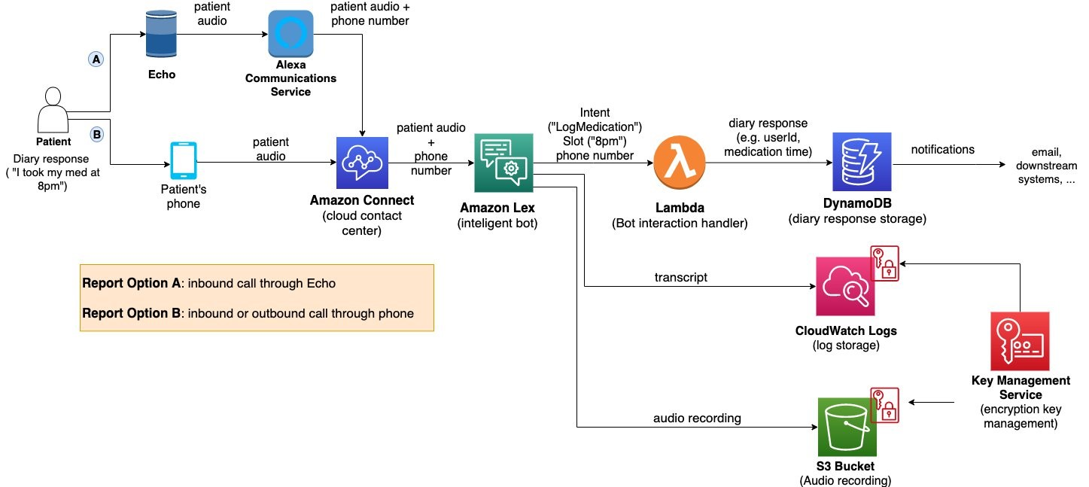

Figure 1: Architecture and data flow of the voice patient diary sample application

**The role of a solution architect**

Since the IT world is changing at a dramatic pace, there has been a lack of consensus when it comes to  [defining the role of a solution architect](https://www.leanix.net/en/wiki/ea/solution-architect) Because just like within the field of enterprise architecture a level of abstraction that might be hard to grasp from a non-technical perspective. It’s dangerous to assume that hiring an enterprise architect who delegates tasks to development teams can cut out the middleman. The solution architect is absolutely necessary to ensure that solutions are implemented correctly.

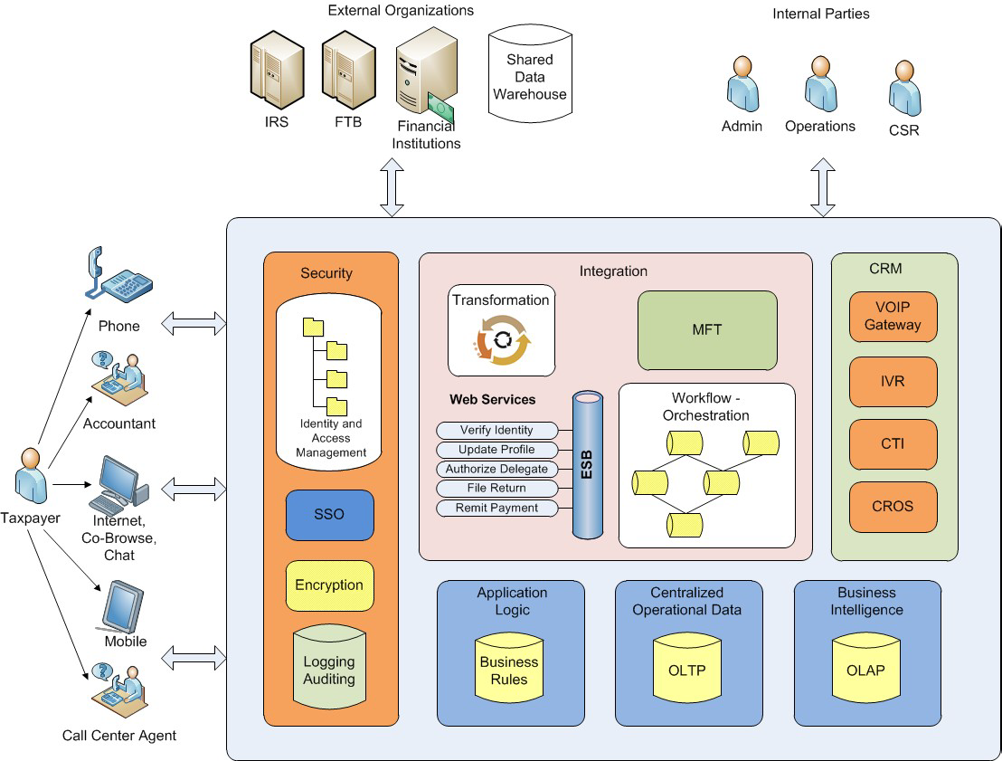

### Information architecture

Information architecture describes how a user interface is structured. To facilitate the use of an e-commerce website, a solution architect can propose a structure that makes the navigation intuitive and user-friendly (e.g., reducing the number of clicks needed to get from A to B).

### Information security architecture

When introducing a new product or system as part of an IT solution, solution architects make sure that it fits into existing information security practices. How the project complies with each regulation is formally documented at the beginning of a project.

### System architecture

The software as service culture has transformed the digital landscape and often demands a system overhaul. Solution architects use system architecture to design new software entities that automate processes. In their conceptual model, they also determine the placement and behaviour of each software component.

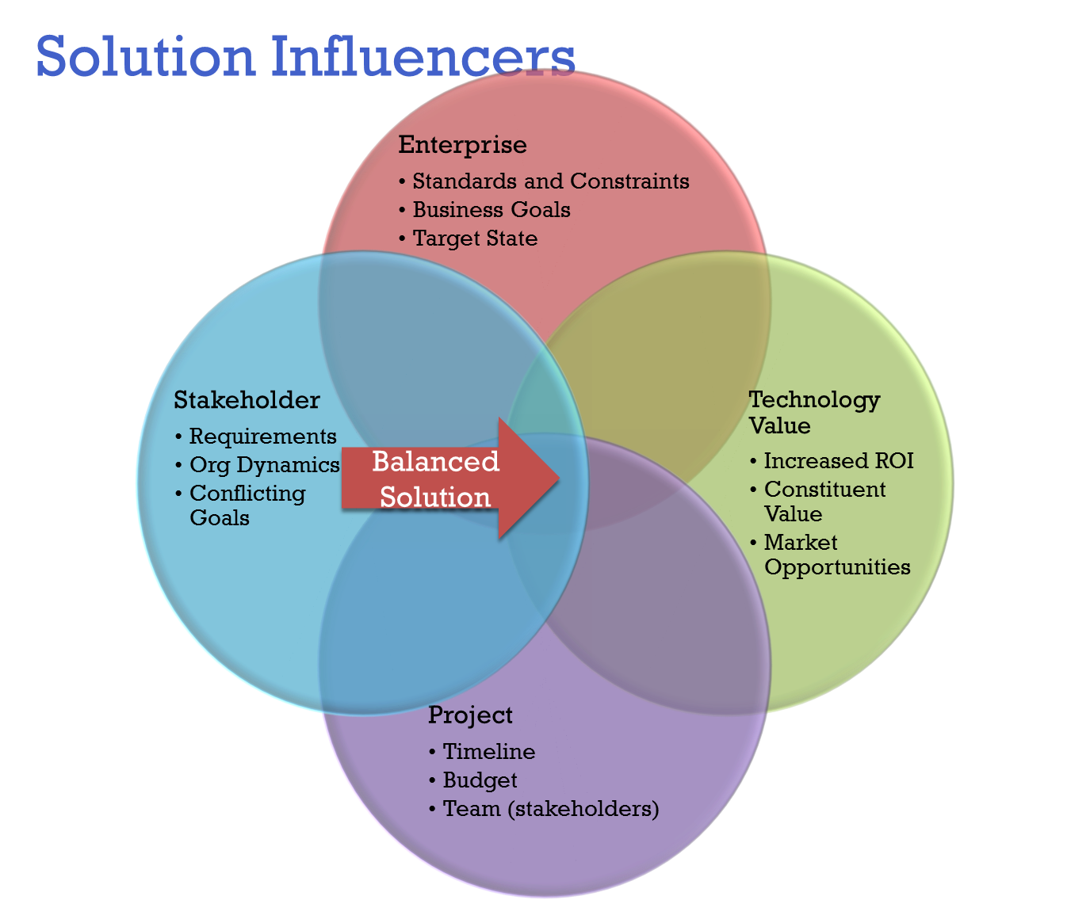

### Application architecture

Systems consist of single software tools or applications that people use to carry out their work. Solution architects rely on application architecture to create a map of all applications (usually in a layered structure) and how they interact with each other.

## Conclusion

In every new IT project, solution architecture is a vital link between the IT strategy of a business and the successful implementation of technical solutions. By looking at a specific problem, [solution architects](https://www.leanix.net/en/wiki/ea/solution-architect) conceptualize the best possible solution while taking all functional and non-functional requirements into account. They formulate clear guidelines that help manage technical teams and outline the development stages of a project from start to finish.